

**AR Navigation (SPSS)**

Version 0.3

**UNCONTROLLED COPY IF PRINTED**

**Version Date: Mar 8, 2019**

**FORD CONFIDENTIALF**

**Revision History**

|  |  |  |  |
| --- | --- | --- | --- |
| **Date** | **Version** | **Notes** | |
| **27 / 3 / 2019** | **0.1** | **Rough Unreleased** |  |
| **29 / 8 / 2019** | **0.2** | **Rough Unreleased** | **Add system diagram, implementation principle** |
| **29 / 10 / 2019** | **0.3** | **Rough Unreleased** | **Add signal (10) description, update system diagram. add destination hint requirements , add guidance arrow requirements** |

**Table of Contents**

Revision History 2

1.1 Purpose 5

1.2 Scope 5

1.3 Audience 5

2 Feature Description 6

2.1 Feature Overview 6

2.2 One Page / PRD **错误!未定义书签。**

3 Architectural Design 7

3.1 Block Diagram 7

3.1.1 IVI Display 7

3.1.2 IVI & Cluster Display 7

3.1.3 IVI & HUD & Cluster Display 7

3.2 System Diagram 7

3.2.1 IVI Display 7

3.2.2 IVI & Cluster Display 8

3.2.3 IVI & HUD & Cluster Display 8

3.3 Primary Use Case 9

4 Functional Definition 10

4.1 AR/2D/Normal View Switch 10

4.1.1 Description 10

4.1.2 Use Case 10

4.1.3 Requirements 10

4.2 Destination Hint 11

4.2.1 Feature Description 11

4.2.2 User Case 11

4.2.3 Requirements 11

4.3 Road Guidance Arrow 11

4.3.1 Feature Description 11

4.3.2 User Case 11

4.3.3 Requirements 12

4.4 AR navigation road switch 12

4.4.1 Feature Description 12

4.4.2 User Case 12

4.4.3 Requirements 13

4.5 Voice Control for AR Navigation 13

4.5.1 Feature Description 13

4.5.2 User Case 13

4.5.3 Requirements 13

4.6 Objects Information Visualization 14

4.6.1 Feature Description 14

4.6.2 User Case 14

4.6.3 Requirements 14

4.7 Lane Departure Reminder 14

4.7.1 Feature Description 14

4.7.2 User Case 14

4.7.3 Requirements 15

4.8 Minimap overview 15

4.8.1 Feature Description 15

4.8.2 User Case 15

4.8.3 Requirements 15

4.9 Front Vehicle Detection 15

4.9.1 Feature Description 15

4.9.2 User Case 16

4.9.3 Requirements 16

4.10 Pedestrian Detection 16

4.10.1 Feature Description 16

4.10.2 User Case 16

4.10.3 Requirements 16

4.11 Obstacles Detection 17

4.11.1 Feature Description 17

4.11.2 User Case 17

4.11.3 Requirements 17

4.12 E-eyes 17

4.12.1 Feature Description 17

4.12.2 User Case 17

4.12.3 Requirements 17

4.13 Interval Velocity Measurement 18

4.13.1 Feature Description 18

4.13.2 User Case 18

4.13.3 Requirements 18

4.14 TSR (Traffic Sign Recognition) 18

4.14.1 Feature Description 18

4.14.2 User Case 18

4.14.3 Requirements 18

5 General Requirements 19

5.1 Center Stack 19

5.2 Camera 19

5.3 Cluster 19

5.4 HMI 19

6 Interface 20

7 Error Handling 21

7.1 Hardware error 21

7.1.1 Camera error 21

7.1.2 Other hardware error 21

7.2 Software error 21

8 Glossary 22

9 Appendix: Reference Documents 23

1. **Introduction**

## Purpose

* The AR navigation is designed to provide user Augmented Reality display on IVI, Cluster or HUD. It visualizes the route to get people to his/her destination in augmented reality with 3D arrows, and overlays of information related to user’s location (streets and POI) where is projected on objectives.

## Scope

* TBD

## Audience

* Core engineering / supplier responsible for developing the AR navigation and its subsystems.
* Supplier responsible for providing AR navigation data.
* Core engineering responsible for developing customer functions that use the AR navigation.

# Feature Description

## Feature Overview

This is a navigation feature that user could have navigation guide arrow visualized and have enhance information of street and POIs projected on IVI screen, Cluster or HUD.

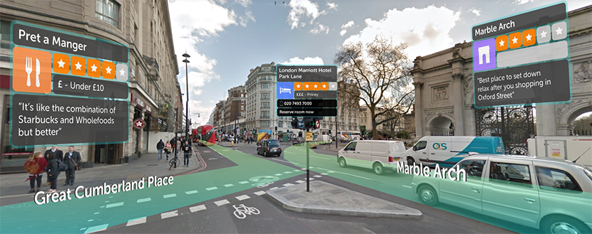

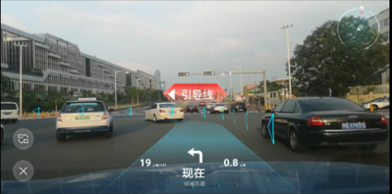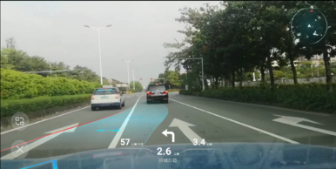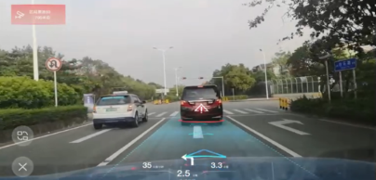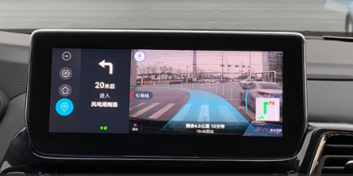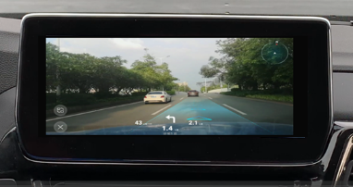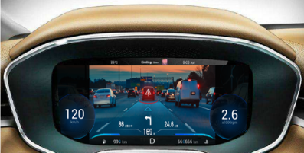

## Implementation Principle

* Camera capture the live video stream of the road in front of the vehicle.
* Then feed this video stream into IVI (DuerOS system) via LVDS cable (coax).
* AR image algorithm was deployed in DuerOS doing image identification, render and merge, etc.
* DuerOS feed completed video stream into Cluster or center stack screen for display via LVDS cable (coax).

# Architectural Design

## Block Diagram

### IVI Display

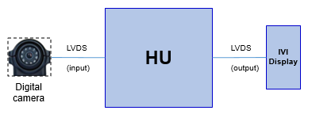

### IVI & Cluster Display

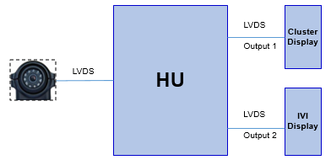

### Cluster Display

## System Diagram

### IVI Display

TBD

### IVI & Cluster Display

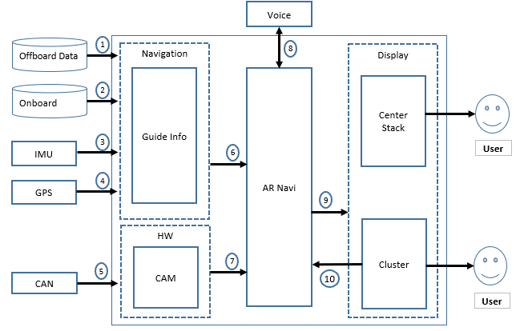

|  |  |
| --- | --- |
| Signal check list | Meaning of Signal |
| 1 | Data send by navigation server to DuerOS system |
| 2 | Data send by navigation onboard database to DuerOS system |
| 3 | IMU signal send by IMU chip to DuerOS system |
| 4 | GPS signal send by GPS module to DuerOS system |
| 5 | CAN "speed" signal send to DuerOS system |
| 6 | Guide info data send to AR module |
| 7 | Camera signal send to AR module |
| 8 | Voice data send by Voice server |
| 9 | Video streaming send to Cluster |
| 10 | Views control signal send to AR module via cluster |

### IVI & HUD & Cluster Display

TBD

## Primary Use Case





# Functional Definition

## AR/2D/Normal View Switch

### Description

* User is allowing to activate AR navigation system and switch AR/2D/Normal view between Cluster and IVI in runtime. (ONLY apply to Cluster & IVI display solution)

### Use Case

|  |  |
| --- | --- |
| **Actors** | * User |
| **Pre-conditions** | * Center Stack Display / IVI Display are both initialized completed |
| **Scenario Description** | * User activate AR system and select AR/2D/Normal view via Cluster or IVI HMI |
| **Post-conditions** | * AR/2D/Normal views has been switched between Cluster and Center Stack. |
| **List of Exception Use Cases** | * N/A |
| **Interfaces** | * TBD |

### Requirements

* The switch logic between Cluster and IVI should follow <View Switch Diagram> below



## Destination Hint

### Feature Description

* AR navigation system project a visualized destination symbol where stick on destination landmark or pass by points, the purpose is to give user a visualized hint that the destination is in front of the vehicle with a specific distance.

### User Case

|  |  |
| --- | --- |
| **Actors** | * User |
| **Pre-conditions** | * Map is activated * Destination has been set and start navigation |
| **Scenario Description** | * User drives vehicle approaching destination or pass by point |
| **Post-conditions** | * Destination visualized symbol with specific distance has appeared in AR view |
| **List of Exception Use Cases** | * N/A |
| **Interfaces** | * N/A |

### Requirements

* Destination visualized symbol should appear in VR view at appropriate timing, which means this symbol needs to be displayed before vehicle is about to reach the point, not too far or not too close. The recommend distance to display this destination symbol between vehicle and destination is about 0.5 or 1 kilometer, depends on project specification.
* Destination visualized symbol should not be displayed where vehicle has very long distance to the destination, or the vehicle has gone pass the destination already.
* Once the destination visualized symbol has been displayed, the size of the symbol should change from small to big according to distance between vehicle to destination (the closer the bigger).
* Destination visualized symbol should not have offset over 5m away of the target (normally, the target will be destination main entrance of front door).
* Destination visualized symbol should disappear once navigation be cancelled or completed.

## Road Guidance Arrow

### Feature Description

* Road Guidance Arrow is a visualized arrow display in AR view overlay the lane where vehicle currently located. The arrow is using for guide user how to drive along the route, when the vehicle needs to change lane and where should take vehicle turning.

### User Case

|  |  |
| --- | --- |
| **Actors** | * User |
| **Pre-conditions** | * Map is activated * Destination has been set and start navigation |
| **Scenario Description** | * User set destination and start navigation |
| **Post-conditions** | * Road guide arrow is displayed and guide user driving |
| **List of Exception Use Cases** | * N/A |
| **Interfaces** | * N/A |

### Requirements

* The guidance arrow should be displayed in AR view after user start navigation.
* The guidance arrow should be translucent that the road should not be obstructed.
* The guidance arrow should overlay the lane where vehicle located, the position of the arrow should be adjusted automatically and move smoothly while vehicle change lanes.
* The size of guidance arrow should not bigger or over the width of the lane.
* If vehicle needs to change lane in advance according to navigation route, the guide arrow should guide user for change lane operation, a visualized change lane arrow should be display and target to the correct lane.
* If vehicle needs to have a turn ahead, the AR system should display another visualized turning guide arrow which located in front of vehicle vertically for turning indicated (except U turn). The turning guide arrow should locate at appropriate position where vehicle can go through. If vehicle needs to turn around ahead, display a U turn arrow is required.
* The shape and size of visualized turning guide arrow should change from small to big according to the distance between vehicle and turning point. (the closer the bigger)
* If vehicle needs go up to viaduct, AR navigation system should affect a visualized “goes up” arrow.
* The guidance arrow should adapt its shape as compressing automatically while vehicle get closer to the front vehicle or any other blocks that vehicle cannot go pass it.
* In any case, the guidance arrow should not penetrate any vehicle in front or any block that vehicle cannot go pass it. The blocks can be vehicles, roadblocks, construction area, accident area etc...

## AR navigation road switch and correction

### Feature Description

* AR navigation route switching and correction automatically after vehicle deviated from established route.

### User Case

|  |  |
| --- | --- |
| **Actors** | * User |
| **Pre-conditions** | * Map is activated * Destination has been set and start navigation |
| **Scenario Description** | * The vehicle deviated from the established route |
| **Post-conditions** | * AR system start to correct user back to the route |
| **List of Exception Use Cases** | * N/A |
| **Interfaces** | * N/A |

|  |  |
| --- | --- |
| **Actors** | * User |
| **Pre-conditions** | * Map is activated * Destination has been set and start navigation |
| **Scenario Description** | * Navigation route change |
| **Post-conditions** | * AR system start to guide user to new route |
| **List of Exception Use Cases** | * N/A |
| **Interfaces** | * N/A |

### Requirements

* AR navigation should switch and correct route automatically after vehicle deviated from established route, the first deviation alert needs to be triggered within 50m of the vehicle’s off-track route.
* AR navigation system should switch the route immediately once vehicle deviated from established route via visualize picture of guide arrow/ turning symbol / etc...
* AR navigation system should correct user back to established route immediately once the vehicle is deviated via visualize picture of guide arrow/ turning symbol / etc...

If vehicle deviated from established route for a certain distance (over 300m), the established route should be replaced by a new route.

* The following case will lead to navigation route changing

1. Navigation route changed by user
2. Vehicle deviated from the established route for a certain distance
3. The alternative route been selected

## Voice Control for AR Navigation

### Feature Description

* User could control the features of AR navigation via voice, a basic voice control commands set is available while AR navigation is activated

### User Case

|  |  |
| --- | --- |
| **Actors** | * User |
| **Pre-conditions** | * Map is activated * AR navigation is activated * Voice control is activated |
| **Scenario Description** | * User wake-up voice system to control AR navigation via AR navigation voice control command set |
| **Post-conditions** | * AR navigation recognize and implement user's intent via voice control |
| **List of Exception Use Cases** | * N/A |
| **Interfaces** | * N/A |

### Requirements

* AR navigation should support voice control via AR navigation voice commands set.
* AR navigation voice control command set should be defined by OEM.
* A basic set of voice command should contain the following commands:

|  |  |
| --- | --- |
| Commands |  |
| 切换（为）AR导航 | Switch to AR navigation |
| 打开AR导航 | Open AR navigation |
| 进入AR导航 | Go to AR navigation |
| 打开实景导航 | Open AR navigation |
| 切换（为）实景导航 | Switch to AR navigation |
| 进入实景导航 | Go to AR navigation |
| 关闭AR导航 | Close AR navigation |
| 关闭实景导航 | Close AR navigation |

## Objects Information Visualization

### Feature Description

* AR navigation system project visualized information onto the according objects in AR view

### User Case

|  |  |
| --- | --- |
| **Actors** | * User |
| **Pre-conditions** | * Map is activated * AR View is switch on |
| **Scenario Description** | * User switch to AR view |
| **Post-conditions** | * Objects' information be projected on according objects on AR view |
| **List of Exception Use Cases** | * N/A |
| **Interfaces** | * N/A |

### Requirements

* Object's information should be projected onto the according object in AR view
* The following object's information should be supported but not limit to
* POI name
* POI address
* POI contact number
* POI ranking score
* Road name
* TBD
* The projected information should locate at the right position where stick to the object. For instance, the road name information should stick on the road or locate at the right position above of the road; POI information should stick on the corresponding POI.
* All kinds of information which can be projected in AR view should support user or OEM configuration. For instance, user can choose their interested information for projection via AR setting, or, OEM can configure what information is allowing to display.

## Lane Departure Reminder

### Feature Description

* AR navigation system give user a visualized indication while vehicle departure lane or pressing the lane line.

### User Case

|  |  |
| --- | --- |
| **Actors** | * User |
| **Pre-conditions** | * Map is activated * AR View is switch on |
| **Scenario Description** | * User switch on AR view * User change lanes without making a turning signal(DAT be activated) |
| **Post-conditions** | * Objects' information be projected on according objects on AR view |
| **List of Exception Use Cases** | * N/A |
| **Interfaces** | * N/A |

### Requirements

* AR system should display a visualized alert while vehicle departure its currently running lane or run over the line of currently running lane.
* The visualized alert should be a line image with striking color (red is recommended) overlay the lane line.
* The visualized warning should be displayed immediately at the time that vehicle "touch" the lane line. the latency should not over than 300ms.
* An alert prompt chime is also required while visualized alert be triggered.
* The visualized alert should off display when vehicle back in the lane or completely run over the lane line.
* AR system should not display departure reminder if vehicle turning light is blinking.
* If the vehicle support DAT feature, AR navigation system will trigger this alert at the same time as the DAT be triggered.
* The feature can be configured on/off via customer or OEM.

## Minimap overview

### Feature Description

* AR navigation system display a Minimap in AR view indicate route overview.

### User Case

|  |  |
| --- | --- |
| **Actors** | * User |
| **Pre-conditions** | * Map is activated * AR View is switch on * Destination has been set and start navigation |
| **Scenario Description** | * User switch on AR view * User set a destination and start navigation |
| **Post-conditions** | * Minimap is displayed in AR view |
| **List of Exception Use Cases** | * N/A |
| **Interfaces** | * N/A |

### Requirements

* AR navigation system should display a Minimap indicate route overview in AR view after user start navigation
* Minimap display area should comply Ford HMI design according to specific project.
* Minimap on/off can be configured via customer or OEM.
* The feature can be configured on/off via OEM.

## Front Vehicle Detection

### Feature Description

* AR navigation system detect the vehicles in front of driver's car and display visualized reminder in AR view.

### User Case

|  |  |
| --- | --- |
| **Actors** | * User |
| **Pre-conditions** | * Map is activated * AR View is switch on |
| **Scenario Description** | * User switch on AR navigation and there are vehicles in front. |
| **Post-conditions** | * A corresponding visualized reminder of ahead vehicle is display |
| **List of Exception Use Cases** | * N/A |
| **Interfaces** | * N/A |

### Requirements

* AR navigation system should recognize the vehicles in front of the driver's car via image recognition technology
* Distance and movement track can be detected by AR navigation system.
* AR navigation system should prompt user in visualized way that if the vehicle in front of the car brake dramatically or running over the lane with unconventional movement.
* The feature can be configured on/off via customer or OEM.

## Pedestrian Detection

### Feature Description

* AR navigation system detect the pedestrian in front of driver's car and display a visualized corresponding prompt in AR view.

### User Case

|  |  |
| --- | --- |
| **Actors** | * User |
| **Pre-conditions** | * Map is activated * AR View is switch on |
| **Scenario Description** | * User switch on AR navigation and there are pedestrians in front |
| **Post-conditions** | * A corresponding visualized reminder of ahead pedestrian is display |
| **List of Exception Use Cases** | * N/A |
| **Interfaces** | * N/A |

### Requirements

* AR navigation system should recognize the pedestrian in front of the driver's car via image recognition technology
* Distance and movement track can be detected by AR navigation system.
* AR navigation system should reminder user in visualized way that if the pedestrian in front of the car are cross the road with unconventional movement
* The feature can be configured on/off via customer or OEM.

## Obstacles Detection

### Feature Description

* AR navigation detect obstacles ahead of the vehicle and give user a visualized reminder

### User Case

|  |  |
| --- | --- |
| **Actors** | * User |
| **Pre-conditions** | * Map is activated * AR View is switch on |
| **Scenario Description** | * User switch on AR and there are obstacles in front |
| **Post-conditions** | * A visualized reminder be displayed in AR view |
| **List of Exception Use Cases** | * N/A |
| **Interfaces** | * N/A |

### Requirements

* AR navigation should recognize obstacles in front of the driver's car and visualized a prompt in AR view.
* AR navigation system should prompt user take avoid operation if there is enough place to pass it. Otherwise system should suggest user stop the vehicle.
* AR navigation system should measure the width between obstacles ensure that vehicle can go through. Otherwise system should suggest user stop vehicle.
* The feature can be configured on/off via customer or OEM.

## E-eyes

### Feature Description

* AR navigation display E-eyes reminder in AR view along the route.

### User Case

|  |  |
| --- | --- |
| **Actors** | * User |
| **Pre-conditions** | * Map is activated * AR View is switch on |
| **Scenario Description** | * User switch on AR navigation and There is E-eyes in front |
| **Post-conditions** | * A visualized reminder be displayed in AR view |
| **List of Exception Use Cases** | * N/A |
| **Interfaces** | * N/A |

### Requirements

* AR navigation system should indicate user in AR view if there is E-eyes in front of vehicle via a visualized alert.
* The feature can be configured on/off via customer or OEM.

## Interval Velocity Measurement Detection

### Feature Description

* AR navigation system display a visualized symbol indicate user vehicle is about to enter interval velocity measurement segment or the vehicle is running in interval velocity measurement segment of the route.

### User Case

|  |  |
| --- | --- |
| **Actors** | * User |
| **Pre-conditions** | * Map is activated * AR View is switch on |
| **Scenario Description** | * User switch on AR navigation * The vehicle is about to enter interval measurement segment |
| **Post-conditions** | * A visualized reminder be displayed in AR view |
| **List of Exception Use Cases** | * N/A |
| **Interfaces** | * N/A |

### Requirements

* AR navigation system should display a visualized symbol indicate user vehicle is about to enter interval velocity measurement segment or the vehicle is running in interval velocity measurement segment of the route.
* The segment required vehicle average speed information is also needed to display in AR view.
* The feature can be configured on/off via customer or OEM.

## TSR (Traffic Sign Recognition)

### Feature Description

* AR navigation system identify traffic sign in front of the vehicle along the route.

### User Case

|  |  |
| --- | --- |
| **Actors** | * User |
| **Pre-conditions** | * Map is activated * AR View is switch on |
| **Scenario Description** | * User switch on AR navigation and There are traffic signs in front |
| **Post-conditions** | * A visualized reminder be displayed in AR view |
| **List of Exception Use Cases** | * N/A |
| **Interfaces** | * N/A |

### Requirements

* AR navigation system needs to identify traffic sign in front of the vehicle along the route.
* Once the traffic sign has been identified, the corresponding information needs to be visualized in AR view. For instance, the speed limit / foggy area / soft roadbed / curves ahead / slippery area etc.
* The feature can be configured on/off via customer or OEM.

# General Requirements

## Center Stack

* Please refer to <AR Navigation Center Stack Performance Requirements>

## Camera

* Please refer to <AR Navigation Camera Performance Requirements>

## Cluster

* Please refer to <AR Navigation Cluster Performance Requirements>

## HMI

* Please refer to <AR Navigation HMI Requirements>

# Interface

* Please refer to <AR Navigation Camera Performance Requirements>

# Error Handling

## Hardware error

### Camera error

* Once the AR camera is not work, user should have a visualized or voice alarm, the AR view should not be activated by system.

### Other hardware error

* Once any other hardware which AR feature dependence is not work, user should have a visualized or voice alarm. The AR view should not be activated by system under such situation.

## Software error

* TBD

# Glossary

|  |  |  |
| --- | --- | --- |
| **Terminology** | **Type** | **Definition** |
| HU | Technical | head unit |
|  |  |  |
|  |  |  |
|  |  |  |
|  |  |  |
|  |  |  |
|  | Business |  |

# Appendix: Reference Documents

|  |  |
| --- | --- |
| Reference # | Document Title |
| 1 | <AR Navigation Camera Performance Requirements> |
| 2 | <AR Navigation Cluster Performance Requirements> |
| 3 | <AR Navigation HUD Performance Requirements> |
| 4 | <AR Navigation Camera Signal and Data Definition> |
| 5 | <AR Navigation Cluster Signal and Data Definition> |